C:\Users\lm7301118\Pictures\images.jpg**Dear Boys, Girls, Parents & Guardians,**

|  |  |  |
| --- | --- | --- |
| 1st February 2016 |  |  |

St. Denis’ Primary Newsletter 7

**Thank You**

We would like to offer a HUGE ‘thank you’ to **Jem Carpets** who supplied and fitted linoleum in our newly established Medical Room for free. The new linoleum makes the room much more cosy & welcoming for our children.

We would also like to say ‘thank you’ to **Costa at the Forge** for supplying our school with the ‘Barney & Echo’ educational resource which deals with issues surrounding drugs, tobacco and alcohol. The books are a fun and interactive resource which follow the story of Barney Eagle and Echo Squirrel.

**Schools’ United Programme – Primary 7 Burns’ Supper Celebration with Haghill Park Primary**

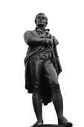There were no 'sleekit, cow'rin, tim-rous beasties' at the Primary 7 Burns’ Supper this week; everybody had their dancing shoes on and took part in a wonderful celebration of Rabbie Burns!  The event consisted of toasts to the lads and lassies, a dramatic address to the haggis by Community Police Officer Tam, performances by the choir and a ceilidh to rival even the best of hootenannies to round the afternoon off! In the poetry recital Emma Smith received the 3rd place prize and Cillian Brand received the 2nd place prize, with the top prize going to Haghill Park's Dannie McNally!  A muckle guid time was had by all and our children were delighted to welcome Haghill Park Primary 7 children as their guests!  Until next time, ‘Haste Ye Back!’ (Ms Pattison)

**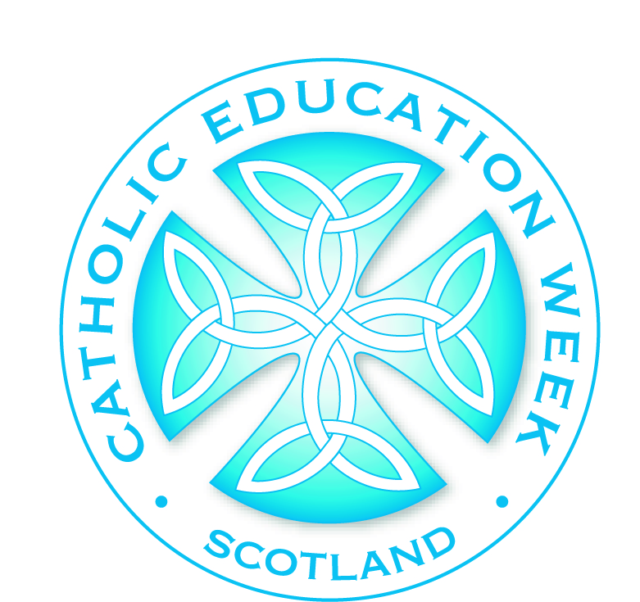*Events/Activities planned during the month of February 2016***

**Catholic Education Week – 31st January – 6th February 2016**

During Catholic Education week we celebrate the importance of educating children and young people in faith. The Bishops of Scotland are inviting us during this Catholic Education Week to reflect on how we are “Learning to be Merciful”. Throughout the course of this week using resources supplied by the Scottish Catholic Education Service (SCES), our teachers will help our children to learn more about their Christian calling to mercy.

*Please see attached information leaflet on Catholic Education Week 2016.*

**Catholic Education Week Masses:**

Our Lady of Good Counsel Parish Church Saturday 30th January 2016 at 5.30pm

Our Lady of Good Counsel Parish Church Sunday 31st January 2016 at 10.00am,

12.00 noon & 5.30pm

St. Anne’s Parish Church Saturday 30th January 2016 at 6.00pm

Sunday 31st January 2016 at 11.30am

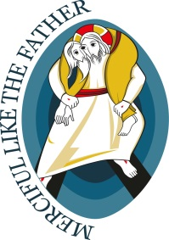Catholic Education Week Assembly ‘Learning to be Merciful’ was held on **Tuesday 26th January 2016**, the week prior to Catholic Education Week. During this Assembly the children learned about:

* Catholic Education Week 2016
* The Year of Mercy
* What ‘mercy’ means?
* Being ‘merciful’
* Living, celebrating and professing our faith in a variety of ways
* Sharing our faith with others.

**Catholic Education Week Assembly – Tuesday 2nd February 2016**

This Assembly will focus on ‘Shine – The Presentation of Jesus in the Temple’. The children will be learning about:

* The importance of light
* That Jesus is ‘The Light of the World
* Shining God’s light – ‘I am unique’
* The Bible story about ‘The Presentation of Jesus in the Temple’.

**Catholic Education Week Workshops – Wednesday 3rd February 2016**

Sister Julia McLoughlin (Sisters of Notre Dame de Namur) will be here to work with the children from Primary 4 (our First Holy Communion class) and the children from Primary 3 (our Reconciliation class).

**Primary 5/4 Educational Trip – Wednesday 3rd February 2016**

The children from Primary 5/4 will visit ‘Glasgow Museum Resource Centre’ as part of their topic on ‘The Romans’. They will be learning about ‘What the Romans did?’



**HELPING OTHERS ‘Wear Red to School Day’ – Friday 5th February 2016**

We have signed up to a **‘Wear it! Beat it!’** event which has been organised for **Friday 5th February 2016**. The children *and staff* will be encouraged to wear **‘something red’** to school on t his date and **donations of £1.00** will be collected for the ***‘British Heart Foundation’***.

**Primary 7 will attend the PreSTEM Launch Event – Monday 8th February 2016**

Primary 7 children will participate in the PreSTEM Launch Event at St. Mungo’s Academy. PreSTEM is an environmentally themed 4 week STEM project. It forms part of a continuum of schemes administered by EDT with one common mission; to inspire students towards STEM related careers by linking education and industry in real life situations using hands on learning and skills development.

**Ash Wednesday Mass – 10th February 2016**

Our **Primary 7** class will lead our Ash Wednesday Mass, on the **10th of February**, at St. Anne’s Parish, 9.30 Mass. As always, we will be looking for Parent Helpers to escort all of the children to and from Mass. Please inform our Office Staff if you are available to help escort our children. Thank you.

**Primary 6 Educational Trip – Thursday 18th February 2016**

The children from Primary 6 will visit St. Mungo’s Museum in Glasgow.

**Primary 3/2 Educational Trip – Thursday 18th February 2016**

As part of their topic on ‘Knights & Castles’ the children from Primary 3/2 will visit Edinburgh Castle.

**Parent Council Meeting - Monday 22nd February 2016**

Our next Parent Council Meeting is on the **22nd February, 6.00pm – 7.00pm**.

**Primary 7 Lenten Mass – Wednesday 24th February 2016**

Our **Primary 7** class will attend Holy Mass, on the **24th of February**, at St. Anne’s Parish, 9.30 Mass. As always, we will be looking for Parent Helpers to escort the Primary 7 children to and from Mass. Please inform our Office Staff if you are available to help escort our children. Thank you.

**Primaries 1 – 4 Flouride Varnish – Wednesday 24th February 2016**

The Childsmile Team will be here all day to ‘flouride varnish’ the teeth of children in Primaries 1, 2, 3 & 4.

**Literacy Week – Monday 29th February – Friday 4th March 2016**

Week beginning Monday 29th February is Literacy Week. In order to ensure that our school is a ‘literacy rich environment’ the children will participate in a number of activities leading up to and during Literacy Week. *More information will follow.*



**February Holiday Dates**

Monday 15th February – Tuesday 16th February 2016 February weekend holiday

Wednesday 17th February 2016 Inset Day 4 (school closed for the children)

**CHILDREN RETURN TO SCHOOL** Thursday 18th February 2016 at 9.00am



**Kind regards,**

**Mrs L Mackie**

**Head Teacher**

***Prayer for the Year of Mercy***

*Lord Jesus Christ,*

*you have taught us to be merciful like the heavenly Father,*

*and have told us that whoever sees you sees Him.*

*Show us your face and we will be saved.*

*Your loving gaze freed Zacchaeus and Matthew from being enslaved by money,*

*the adulteress and Magdalene from seeking happiness only in created things,*

*made Peter weep after his betrayal,*

*and assured Paradise to the repentant thief.*

*Let us hear, as if addressed to each one of us,*

*the words that you spoke to the Samaritan woman:*

*“If you knew the gift of God!”*

*You are the visible face of the invisible Father,*

*of the God who manifests his power above all by forgiveness and mercy:*

*let the Church be your visible face in the world, its Lord risen and glorified.*

*You willed that your ministers would also be clothed in weakness*

*in order that they may feel compassion for those in ignorance and error:*

*let everyone who approaches them feel sought after, loved, and forgiven by God.*

*Send your Spirit and consecrate every one of us with its anointing,*

*so that the Jubilee of Mercy may be a year of grace from the Lord,*

*and your Church, with renewed enthusiasm, may bring good news to the poor,*

*proclaim liberty to captives and the oppressed,*

*and restore sight to the blind.*

*We ask this of you, Lord Jesus, through the intercession of Mary, Mother of*

*Mercy; you who live and reign with the Father and the Holy Spirit for ever and ever.*

*Amen.*

